Data structures and Algorithms
Name: NALLANI LOKAKALYAN
Registered Mail: 2300030853cseh1@gmail.com

Exercise 2:
package Data_structures_and_Algorithms;
import java.util.Arrays;
import java.util.Comparator;
public class Exercise_2 {
static class Product {
int productId;
String productName;
String category;
public Product(int productId, String productName, String category) {
this.productId = productId;
this.productName = productName;
this.category = category;
}
public String toString() {
return "Product ID: " + productId +
", Name: " + productName +
", Category: " + category;
}
}
public static Product linearSearch(Product[] products, int targetId) {
for (Product product : products) {
if (product.productId == targetId) {
return product;
}
}
return null;
}
public static Product binarySearch(Product[] products, int targetId) {
int left = 0;
int right = products.length - 1;
while (left <= right) {
int mid = (left + right) / 2;
if (products[mid].productId == targetId) {
return products[mid];
} else if (products[mid].productId < targetId) {
left = mid + 1;
} else {
right = mid - 1;
}
}
return null;
}
public static void main(String[] args) {
Product[] products = {
new Product(105, "Laptop", "Electronics"),
new Product(101, "Mobile", "Electronics"),
new Product(104, "Shoes", "Fashion"),
new Product(102, "Watch", "Accessories"),
new Product(103, "Book", "Education")
};
int searchId = 103;
System.out.println("=== Linear Search ===");
Product result1 = linearSearch(products, searchId);
if (result1 != null) {
System.out.println("Product Found: " + result1);
} else {
System.out.println("Product Not Found");
}
Arrays.sort(products, Comparator.comparingInt(p -> p.productId))
System.out.println("\n=== Binary Search ===");
Product result2 = binarySearch(products, searchId);
if (result2 != null) {
System.out.println("Product Found: " + result2);
} else {
System.out.println("Product Not Found");
}
System.out.println("\n=== Analysis ===");
System.out.println("Linear Search Time Complexity:");
System.out.println("Best Case: O(1)");
System.out.println("Average Case: O(n)");
System.out.println("Worst Case: O(n)");
System.out.println("\nBinary Search Time Complexity:");
System.out.println("Best Case: O(1)");
System.out.println("Average Case: O(log n)");
System.out.println("Worst Case: O(log n)");
System.out.println("\nConclusion:");
System.out.println("Binary Search is more efficient for large datasets");
System.out.println("because it reduces the search space by half in each step.");
System.out.println("However, the array must be sorted before performing Binary Search.");
}
}

Output Screenshot:
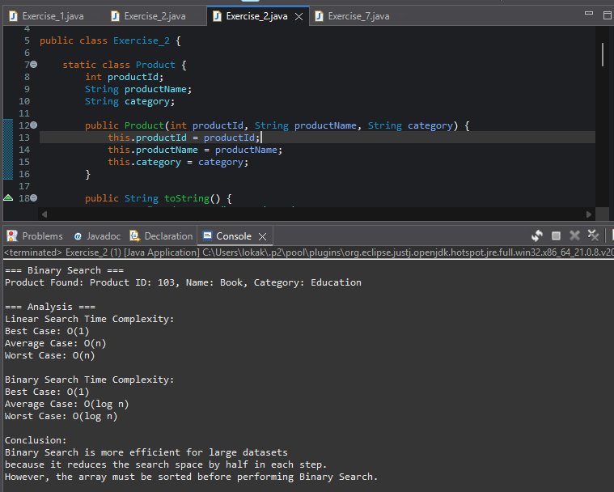

Exercise 7:

package Data_structures_and_Algorithms;
public class Exercise_7 {
public static double predictFutureValue(double currentValue, double growthRate, int years) {
if (years == 0) {
return currentValue;
}
return predictFutureValue(currentValue * (1 + growthRate), growthRate, years - 1);
}
public static void main(String[] args) {
double currentValue = 10000; // Initial investment
double growthRate = 0.10; // 10% annual growth
int years = 5;
double futureValue = predictFutureValue(currentValue, growthRate, years);
System.out.println("=== Financial Forecasting ===");
System.out.println("Current Value : Rs." + currentValue);
System.out.println("Growth Rate : " + (growthRate * 100) + "%");
System.out.println("Years : " + years);
System.out.printf("Future Value : Rs.%.2f%n", futureValue);
System.out.println("\n=== Analysis ===");
System.out.println("Recursion:");
System.out.println("A recursive function calls itself until a base condition is met.");
System.out.println("\nTime Complexity:");
System.out.println("O(n), where n is the number of years.");
System.out.println("\nOptimization:");
System.out.println("1. Use Iteration instead of Recursion.");
System.out.println("2. Use Memoization for complex recursive problems.");
System.out.println("3. Direct Formula: Future Value = Present Value * (1 + rate)^years");
}
}

Output Screenshot:
